Transaction Approval Rules Solution

Exercise 1: Investigation

1. Disable all Initial Reserve Rules that pertain to auto claims before creating these reserve lines. Reload changed classes.

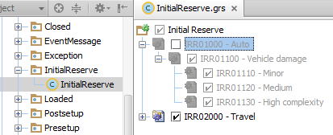

1. Follow these instructions to create transactions that require approval.
   1. Log on to ClaimCenter as Betty Baker. She is an auto adjuster. Using the quick claim wizard, create a new personal auto claim using the policy issued to Larry Gamney. Use "Rollover" as the loss cause.
   2. Create a “Medical Payments” exposure for the insured. Make up a corresponding injury for Larry Gamney.
   3. Create two reserve lines simultaneously for the exposure:

* Claim Cost - Medical - $10,000
* Claim Cost – Unspecified cost type/category - $10,000

1. If you get a validation warning when you click Save on the Set Reserve screen, you can ignore it.
2. The transactions require approval. How would an end user know this?  
   The Financials Transactions list shows that the reserve's status is "Pending approval".
3. What is the reason the transactions require approval? How would an end user be able to determine this?  
   The total reserves for all exposures on the claim exceeds $15,000.00, the base application authority limit of an adjuster.  
   A ClaimCenter user could learn this by viewing the transaction's Reserve Details. (Clicking the Amount cell in the Transaction list brings up this information).
4. Log on to ClaimCenter as su/gw and view the Adjuster Limit Profile to learn where the $15,000 limit is set. Administration > Users & Security > Authority Limit Profile.

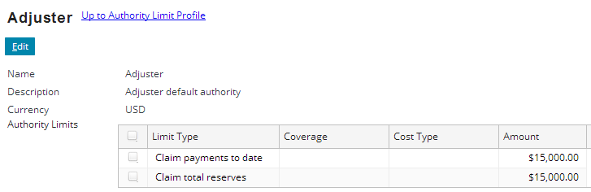

1. Do the two transactions belong to the same transaction set? Where in the user interface can you verify this?  
   Yes. They are both listed in the Transaction detail view's Reserves in Group list.
2. Who is responsible for providing approval? What is the ruleset and rule name that assigned this approval request to this individual?  
   Sue Smith. (She is listed as the User in the only item in the Approval History list.) The "ARR02000 - Try to assign to group supervisor" rule in the ApprovalRouting Approval Rules Rules.
3. Log onto ClaimCenter as the person who is supposed to approve the transactions. Is it possible to approve one reserve and reject the other? What is it about the user interface that makes this possible or impossible?  
   No, it is not possible. Both transactions are listed in a single approval activity, with a single Approve and Reject button. Whichever button you click will affect both transactions.
4. Re-enable all Auto Initial Reserve rules (IRR01000 – Auto).

**Exercise 2: Configuration**

Configure ClaimCenter to meet the following customer requirement from Acme Insurance.

**Requirement 1: Approval for Reserves on claims where fault rating is unknown**

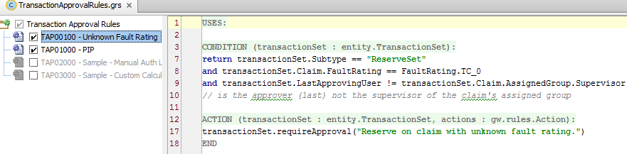

CONDITION:

return transactionSet.Subtype == "ReserveSet"

and transactionSet.Claim.FaultRating == FaultRating.TC_0

and transactionSet.LastApprovingUser != transactionSet.Claim.AssignedGroup.Supervisor

// is the approver (last) not the supervisor of the claim's assigned group

ACTION:

transactionSet.requireApproval("Reserve on claim with unknown fault rating.")

**Requirement 2: Approval for Year-Old Supplemental Payments**

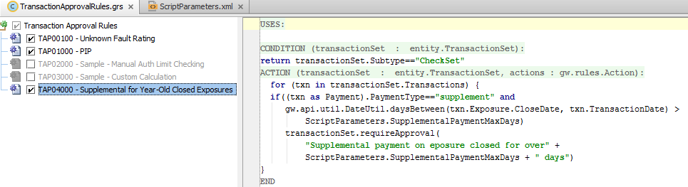

CONDITION:

transactionSet.Subtype=="CheckSet"

ACTION:

for (txn in transactionSet.Transactions) {

if((txn as Payment).PaymentType=="supplement" and

gw.api.util.DateUtil.daysBetween(txn.Exposure.CloseDate, txn.TransactionDate) >

ScriptParameters.SupplementalPaymentMaxDays)

transactionSet.requireApproval(

"Supplemental payment on eposure closed for over" +

ScriptParameters.SupplementalPaymentMaxDays + " days")

}